SRPP supplementary report DA-2021/1279 (PPSSTH-131)
- EXECUTIVE SUMMARY
Reason for consideration by Local Planning Panel – Determination
The proposal was referred to the SRPP for determination on 30 August 2022, being regionally significant development requiring determination by the Regional Planning Panel (Council related development over $5 million). The record of the deferral at Attachment 1. This report should be read in conjunction with eh report to the Panel of 30 August 2022.
Proposal
Warrawong District Community Centre and Library.
Permissibility
The site is zoned B3 City Centre pursuant to Wollongong Local Environmental Plan 2009. The proposal is categorised as a community facility and is permissible in the zone with development consent.
Consultation
The proposal was notified in accordance with Council’s Community Participation Plan and received one (1) submission. The amendments made to the design in response to the deferral were minor in nature and did not warrant renotification.
Recommendation
The applicant has submitted amended plans and documentation that are considered to address the concerns raised by the SRPP and the body of this report addresses the reasons for deferral. The application is recommended for approval subject to the draft conditions at Attachment 4.
- PANEL CONSIDERATION AND DECISION:
The panel agreed to defer the determination of the matter until a supplementary assessment report is provided by council to address the following matters;
- car parking assessment
- arrangements for accessible parking/drop off in Greene St to reduce travel distance (compared to accessible spaces in the proposed car park) and arrangements for covered access.
- likely impacts of road closure on adjoining businesses
- physical impacts of closing the road and the need for a ROW from a risk and traffic management perspective.
- resolution of flooding issues including floodgate impacts, BCA compliant access in the event of flood evacuation requirements, and consideration of path of travel (including for people with a disability)
- visual illustration of how access to the facility will interface with the required floor levels
- demonstration of compliance with LEP Clause 7.13(3) of the WLEP 2009 in relation to the number of entrances, noting this may require submission of a Clause 4.6 variation request.
- review of condition 8 to provide greater clarity
- review of conditions 16 and 20 to remove any duplication
- inclusion of a draft condition requiring a hazardous materials survey prior to demolition
- revision of Condition 1 to include a reference to the SEE and associated technical reports (or alternatively reference the SEE and technical reports explicitly in operational conditions). In particular, the recommendations of the Douglas Partners PSI, Fire Safety Schedule, and Acoustic Report are required to be referenced within the draft conditions of consent.
- The Council is requested to update their assessment within 4 weeks of the date of the publication of the Record of Deferral.
- When this information has been received, the panel will determine the matter electronically. The Panel expects an addendum assessment report from Council responding to the material and the matters raised above.
- ACTIONS FOLLOWING MEETING
The matters required to be addressed by the Panel are discussed in turn below.
Car parking assessment
The application was supported by a Traffic Impact Assessment (12 October 2021 prepared by TTW Structural Civil Traffic Façade) which undertook surveys of parking demand and peak car park usage for both Thirroul Library and Community Centre and Dapto Ribbonwood Centre. An excerpt of that report is contained at Figure 1 below.
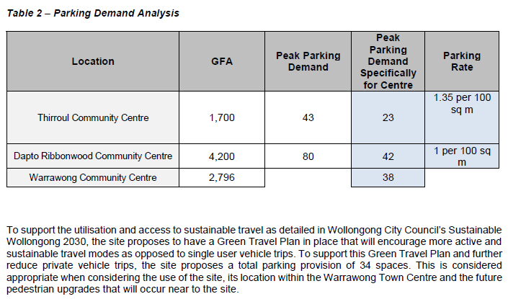
Figure 1: Parking table
The predicted peak car parking demand for the proposal was based on a comparison with those existing facilities which resulted in an expected peak of 38 vehicles. The proposed parking is 34 spaces, the shortfall justified through adoption of a Green Travel Plan and the convenient location of the site to the Warrawong town centre, residential areas and public transport routes.
This approach is consistent with section 7.4 of Chapter E3 of the DCP which notes Council has the discretion to waive or reduce the minimum number of car spaces required for a particular site if the reduced provision can be justified in the accompanying Car Parking and Traffic Impact Assessment study, in terms of:
(a) The amount of public car spaces in the locality;
(b) Proximity to public transport nodes;
(c) Opportunity for cross utilisation with another use; and
(d) An empirical assessment of car parking
With regard to public transport, the site is a short distances to a number of bus stops on Cowper Street as illustrated below.
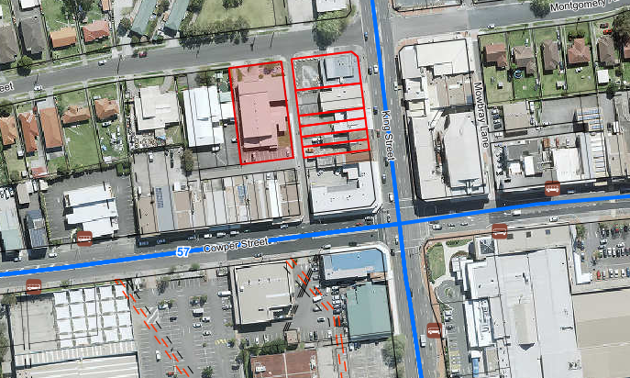
The application has been reviewed by Council’s Traffic Officer who has supported the proposed parking arrangements.
Arrangements for accessible parking/drop off in Greene St to reduce travel distance (compared to accessible spaces in the proposed car park) and arrangements for covered access.
The proposal always envisaged provision of a dedicated passenger drop off point adjacent to the café close to the entrance to the building for people with mobility impairment. This is however required to be managed separately through the Wollongong Traffic Committee. It is worth noting that adjacent to the existing community centre on Greene Street there are currently two accessible spaces on the street. These spaces would no longer be required at that location and could be readily transferable to the new location. Condition 10 of the consent requires commencement of the Traffic Committee process following approval. The proposal also involves removal of a redundant driveway crossing, thereby creating the opportunity for additional kerbside parking space on Greene Street.
Likely impacts of road closure on adjoining businesses
The proposal does not propose a road closure. The lane will remain a road so as to maintain access for services. The repositioned laneway will not hinder access to the small number of businesses that currently utilise it. The reconfiguration will result in additional traffic and a slowing of movement through the lane as a result of the 90 degree parking located along the new section. Suitable turning movements are preserved for the likely service vehicles. The northern portion of the laneway is further made two way which will facilitate egress for businesses to Greene Street. The reconfiguration is not expected to detrimentally impact on any adjoining business.
Physical impacts of closing the road and the need for a ROW from a risk and traffic management perspective.
The realigned section of the lane will remain in public ownership under the management of Council and will not warrant a right of way as would be the case if it were private land.
With regard to risk and traffic management, the expected through traffic movement is expected to be low. There are a small number of businesses relying on access to the lane. Through traffic is not significant given other convenient traffic routes to access Cowper Street from Green Street. The traffic environment is slow moving by virtue of the narrow width and short length of the subject section of laneway. The entry to the lane will further be pedestrian priority with a vehicle crossing rather than kerb and gutter. Sight lines for vehicles are not impeded by structures. Conditions 36 and 37 are further recommended with regard to sight lines and installation of a traffic calming device (e.g. speed hump). This has been supported by Council’s Traffic Officer.
Resolution of flooding issues including floodgate impacts, BCA compliant access in the event of flood evacuation requirements, and consideration of path of travel (including for people with a disability)
The application has been amended to comply with both flooding requirements and BCA access. This has been resolved through an amendment to the contours of the landscaped forecourt area which result in reduced height of flood water adjacent to the building and removal of the need for flood gates at the main entry to the building. Conditions 27 and 30 have been amended to reflect those changes and this has been supported by Council’s Manager Development Engineering. No changes were required to the building itself. The Landscape Plan has been amended as contained at Attachment 2.
Visual illustration of how access to the facility will interface with the required floor levels
The changes to the forecourt contours to not affect accessible paths of travel, nor the internal floor levels. Accessible paths of travel are illustrated on the Landscape Plan at Attachment 2.
Demonstration of compliance with LEP Clause 7.13(3) of the WLEP 2009 in relation to the number of entrances, noting this may require submission of a Clause 4.6 variation request.
The applicant has submitted a clause 4.6 variation request in regard to clause 7.13 of the LEP as contained at Attachment 3. An assessment against clause 4.6 is contained below.
WLEP 2009 clause 4.6 proposed development departure assessment
Development departure | 7.13 Certain land within business zones  (1) The objective of this clause is to ensure active uses are provided at the street level to encourage the presence and movement of people.  (2) This clause applies to land in Zone B1 Neighbourhood Centre, Zone B2 Local Centre, Zone B3 Commercial Core or Zone B4 Mixed Use, but does not apply to land to which clause 7.19 applies.  (3) Development consent must not be granted for development for the purpose of a building on land to which this clause applies unless the consent authority is satisfied that the ground floor of the building--  (a) will not be used for the purpose of residential accommodation, and  (b) will have at least one entrance and at least one other door or window on the front of the building facing the street other than a service lane.
Is the planning control in question a development standard | Yes
4.6 (3) Written request submitted by applicant contains a justification:
that compliance with the development standard is unreasonable or unnecessary in the circumstances of the case, and | Yes
that there are sufficient environmental planning grounds to justify contravening the development standard. | Yes
4.6 (4) (a) Consent authority is satisfied that:
the applicant’s written request has adequately addressed the matters required to be demonstrated by subclause (3), and | The written request has adequately addressed the matters required to be addressed under subclause (3) and is based on the following rationale:  - Entry from King Street is not considered ideal given the pedestrian environment on King Street is characterised by heavy vehicle traffic.  - The main entry facing the public square, lane and car parking provides an integrated space connecting visitors into the building.  - Whilst there is not a direct door to Greene Street, the end of the terrace area opens directly to the street and is a clearly visible access point into the building. This is not dissimilar to a recessed door or foyer entry.  - The layout also responds to the flooding constraints and necessary levels.  - An entry to King Street would present challenges in achieving accessible travel due to the level change.
the proposed development will be in the public interest because it is consistent with the objectives of the particular standard and the objectives for development within the zone in which the development is proposed to be carried out, and | The objective of the standard is:  - to ensure active uses are provided at the street level to encourage the presence and movement of people.  The proposal is not considered to have any consequential adverse impacts on this objective and the design is considered to respond to the unique site constraints and integrate with the public square, lane and car parking areas.  The development provides an active use at street level and the Glazing to each frontage to facilitate passive surveillance of the public domain and a aesthetically pleasing façade.  The use itself will generate significant movement of people to and around the site.  The objectives of the zone are as follows:  - To provide a wide range of retail, business, office, entertainment, community and other suitable land uses that serve the needs of the local and wider community.  - To encourage appropriate employment opportunities in accessible locations.  - To maximise public transport patronage and encourage walking and cycling.  - To strengthen the role of the Wollongong city centre as the regional business, retail and cultural centre of the Illawarra region.  - To provide for high density residential development within a mixed use development if it—  (a) is in a location that is accessible to public transport, employment, retail, commercial and service facilities, and  (b) contributes to the vitality of the Wollongong city centre.  The variation has regard to these objectives. The building complies with other development standards. The urban form is considered to exhibit design excellence.  It is considered that there is no public benefit in requiring strict compliance with the standard in this instance as entry from King Street is not ideal given the pedestrian environment on King Street. The main entry faces the public square providing an integrated space connecting visitors to the building. The end of the terrace area opens directly to the street and is a clearly visible access point into the building. The layout responds to the unique flooding constraints and necessary levels and achieves accessible travel.  Given the proposal is consistent with the zone objectives and the objectives of Clause 7.13 despite the development departure, the development is considered to be in the public interest in this instance. It is considered that the underlying objective of the standard and the zone are satisfied and that strict compliance with the standard is unreasonable and unnecessary in the unique circumstances of this case.  The proposal will not hinder the attainment of the objectives specified in section 5(a)(i) and (ii) of the EP&A Act.
the concurrence of the Secretary has been obtained. | The SRPP can exercise assumed concurrence in this instance as the consent authority.

Review of condition 8 to provide greater clarity
Draft condition 8 previously stated the following:
- Number of Persons Accomodated
The number of persons accommodated during the use of the premises shall be limited to the following:
Room/Area | Number of People
Level 2 (assembly) | 320
TOTAL CAPACITY (level 2 Assembly) | 320
Install a sign displayed in a prominent position in the building stating the maximum number of persons, as specified above, that are permitted in the building.
This condition relates to the community hall on level 2 as detailed in the BCA Statement prepared by Group DLA accompanying the DA. For greater clarity, the condition has been amended to the following:
- Level 2 maximum capacity
The number of persons accommodated on level 2 of the building shall be limited to the following:
Area | Number of People
Level 2 (assembly) | 320
TOTAL CAPACITY (level 2) | 320

Review of conditions 16 and 20 to remove any duplication
This has been resolved in the draft conditions at Attachment 4.
Inclusion of a draft condition requiring a hazardous materials survey prior to demolition
This is now contained at condition 35 of the draft conditions at Attachment 4.
Revision of Condition 1 to include a reference to the SEE and associated technical reports (or alternatively reference the SEE and technical reports explicitly in operational conditions). In particular, the recommendations of the Douglas Partners PSI, Fire Safety Schedule, and Acoustic Report are required to be referenced within the draft conditions of consent.
It is not common practice for Council to include reference to supporting documents in condition 1. Rather, separate conditions include reference to those documents where necessary.
The SEE does not contain detail that needs to be reflected in the conditions of consent.
Condition 33 of the draft consent references recommendations contained in the PSI.
Condition 34 of the draft consent references the recommendations contained in the Acoustics Report.
Council’s BCA Officer has advised that no specific condition is required in regard to a fire safety schedule.
- CONCLUSION:
This supplementary report and the amendments to the plans are considered to satisfactorily address the reasons for deferral by the Panel and the application is recommended for approval subject to the draft conditions at Attachment 4.

Attachments
1 SRPP Deferral letter
2 Plans
3 Clause 4.6 variation (Clause 7.13 of WLEP 2009)
4 Draft consent

